Here is a photo of 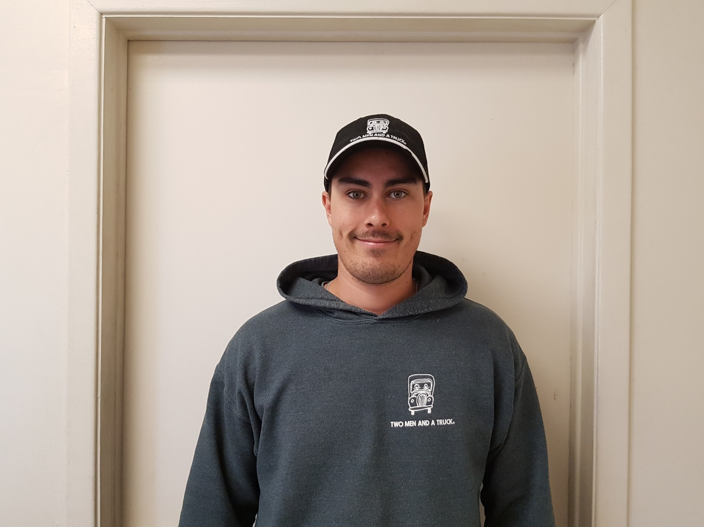

Andrew started with Two Men And A Truck Oshawa, in October, 2013. He started as a mover for a couple of months before training to become a driver. Andrew has been a driver for us since Jan 2014. Andrew was well liked with the other employee’s and quickly became their favorite to work with. Last year Andrew had a 100% referral rating with our customers. He follows our core values which makes him an asset to our company. In January of 2018 Andrew was promoted to Move Manager. He helps train new drivers and movers, as well has taken on truck maintenance and and log book tracking. We find ourselves lucky to have Andrew as a part of our team.

Please feel free to word this differently if need be.

Andrew has to say-

It has been exciting taking on my new role as Move Manager. We have a great group of drivers and movers right now, and I look forward to working with them going forward.
I like working for a company that sees the potential in their employees to move them forward.

Again word as you feel fit.

Thanks
Kari

